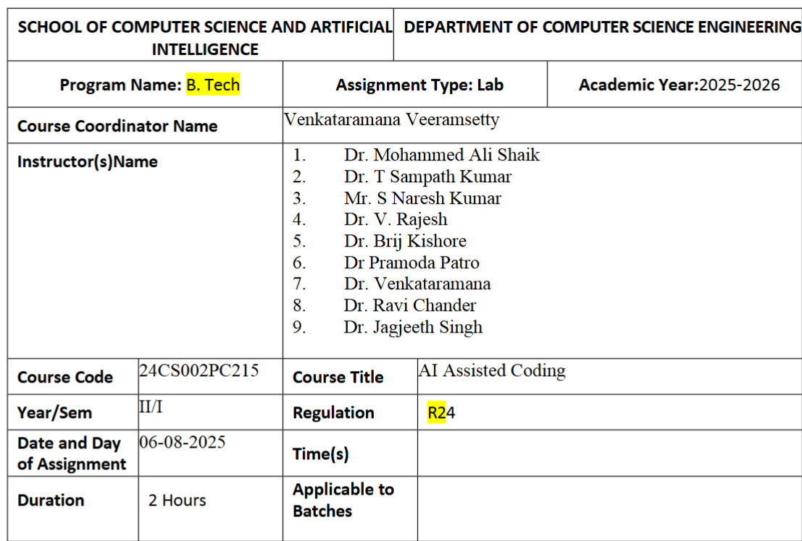
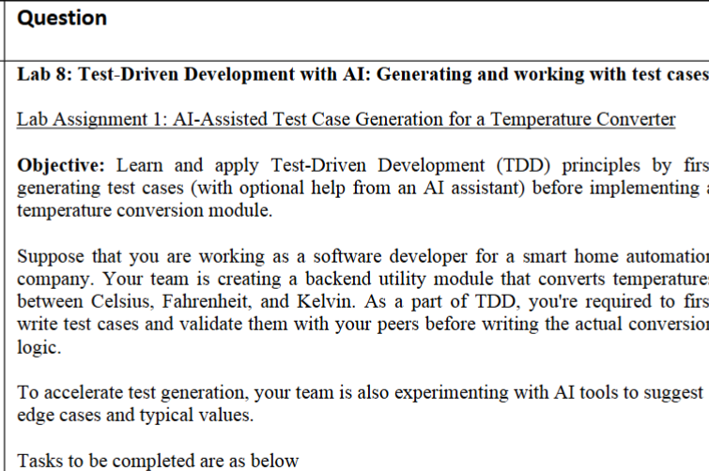
- Define Requirements:
• Convert between Celsius, Fahrenheit, and Kelvin (both directions).
• Handle edge cases like absolute zero and boiling point of water.
• Throw errors for invalid inputs (e.g., negative Kelvin).
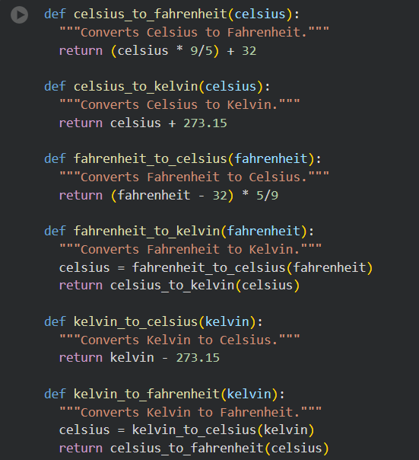
- Write Test Cases First:
• Use unit test or pytest in Python to define at least 10 test cases.
• Get suggestions for additional edge case test scenarios using ChatGPT or any
AI model
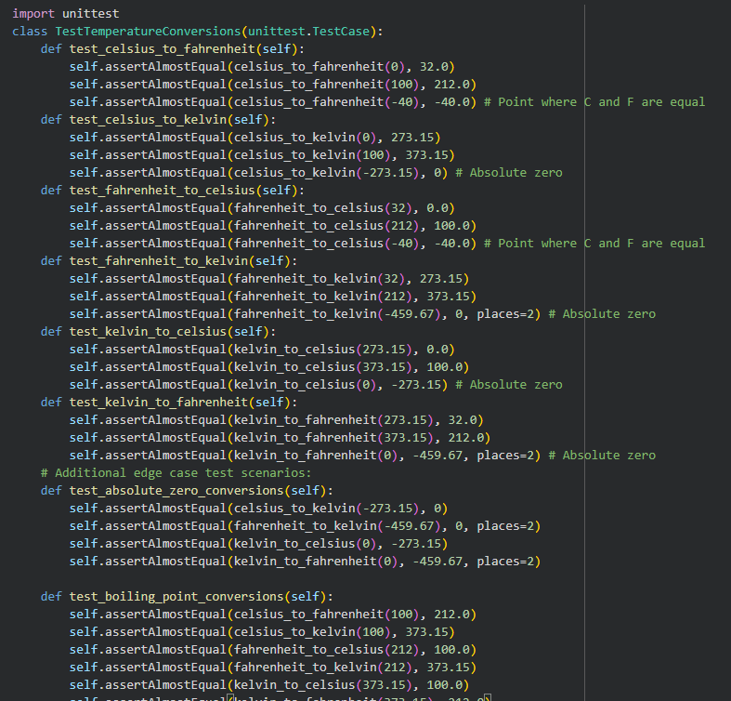
- Implement Conversion Functions:
• Write clean, modular code to pass all test cases
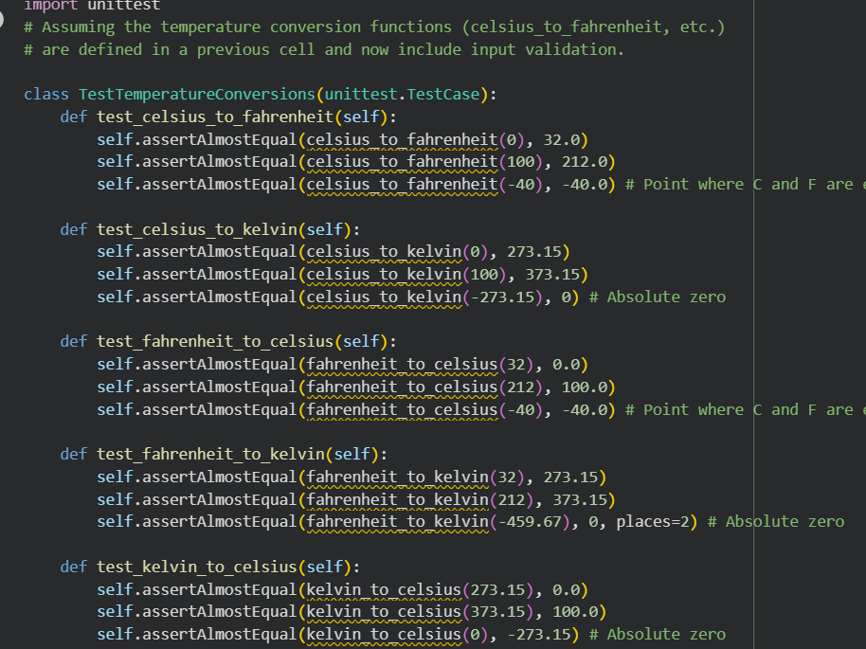
- Refactor Based on Test Results:
• Make sure all tests passes.
• Add new tests if any corner cases are discovered during implementation.
• Use spaCy or NLTK to extract city names from user input.
• Convert natural language queries to appropriate API parameters
